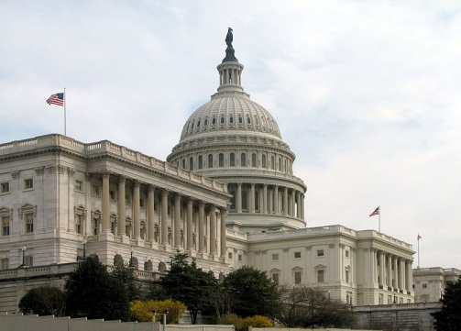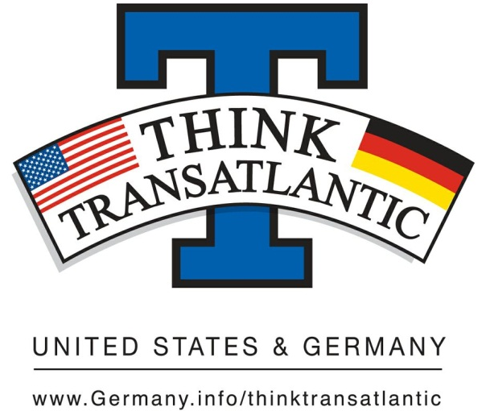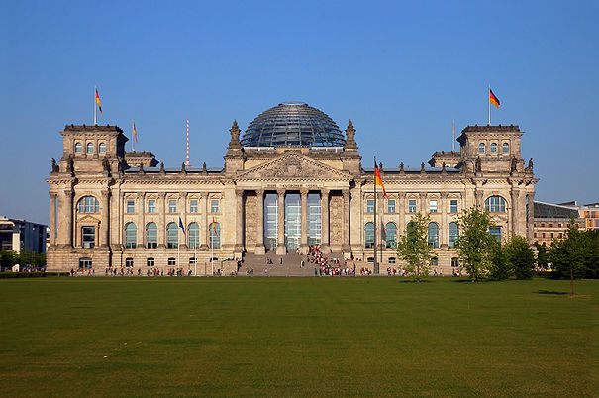

Think Transatlantic Campus Week
October 1st – October 5th, 2012

Monday October 1st
Trivia Game & Information Table in front of the Mailboxes (noon – 2pm)

Film Showing (6pm – 8pm, BUR 203)

Tuesday October 2nd
Trivia Game & Information Table in front of the Mailboxes (noon – 2pm)

Wednesday October 3rd
German Style Food for Lunch at the Commons

Information Table in front of the Mailboxes (noon – 2pm)

Workshop: German Unification & Blog Presentations (4–5:30pm, BUR 203,
refreshments & snacks)

Thursday October 4th
Trivia Game & Information Table in front of the Mailboxes (noon – 2pm)

Friday October 5th
Scavenger Hunt (2pm – 4pm)
(Get your first clue at the Information Table in front of the Mailboxes –
the winner receives a $50 gift card from Amazon)

Essays are due at 5pm – please send submissions to jatzler@washjeff.edu

